**Math 120  
1.2 Basics of Functions and Their Graphs**

# Objectives:

1. Find the domain and range of a relation.

2. Determine whether a relation is a function.

3. Determine whether an equation represents a function.

4. Evaluate a function.

5. Graph functions by plotting points.

6. Use the vertical line test to identify functions.

7. Obtain information about a function from its graph.

8. Identify the domain and the range of a function from its graph.

9. Identify the intercepts from a function’s graph.

We begin this class with learning some fundamentals about functions and their graphs. **This whole class is about different types of functions and how we can use functions to model real world situations!** Let’s start by looking at the application problem on the last page of your Study Guide – our lesson today will prepare you to answer these types of questions about functions.

# Topic #1: Introduction to Relations and Functions

**Relations:** Two quantities that are related can be expressed as an ordered pair . Any set of ordered pairs form a **relation** where is the domain and is the range.



*Example #1 -* Consider the set of 5 ordered pairs for the following relation:



This is a relation since each ordered pair relates an value with a corresponding value.

The **___________** is the set of the -values:



The **___________** is the set of the -values:



Functions: A function is a special relation where each number in the **_________** (the x-values) corresponds to ***________________*** number in the **____________** (the y-values). In other words, a relation is a **function** if _______________________________________



*Example #1 continued* -

Is this a function?

This is a function since none of the ________________ repeat. In other words, each unique x-value is paired with exactly one y-value!



*Example #2*- Is this a function?



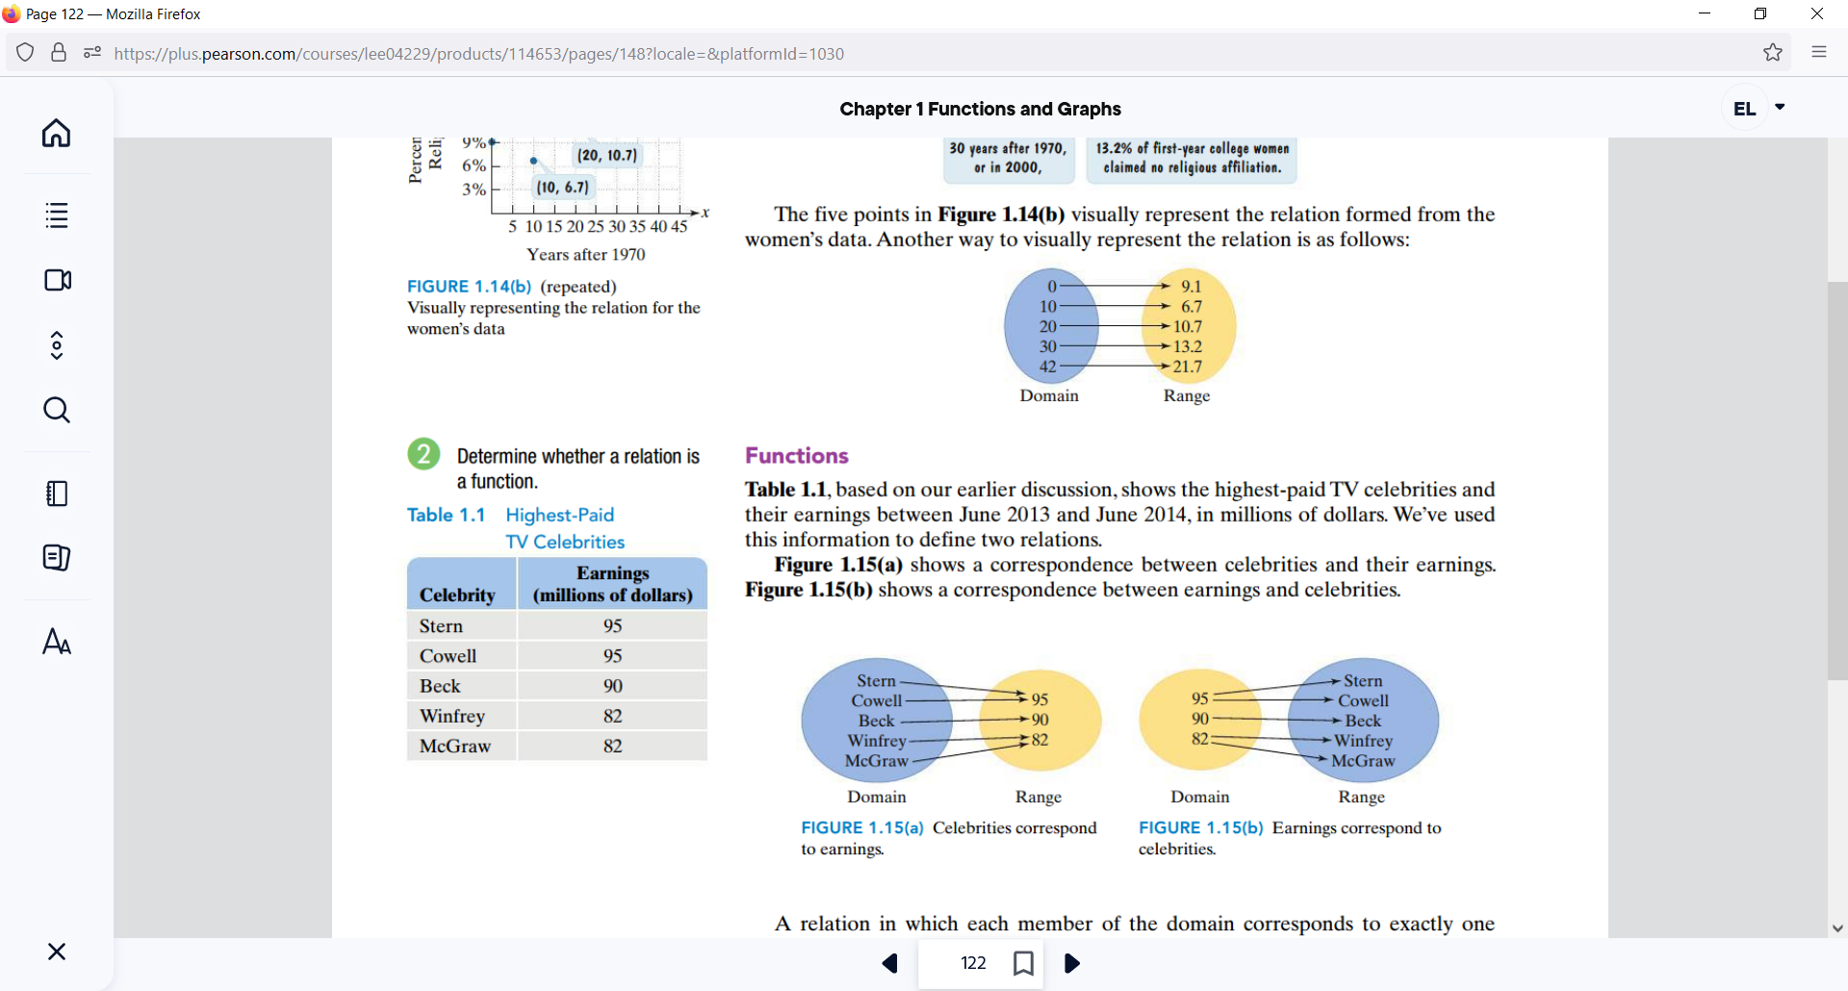



*YOU TRY #1*:

Determine if the Relation is a Function, explain why or why not and state the Domain and Range in either case.



c) {(0, 2), (-1, 1), (2, 0), (-1, 2)}



# Topic #2: Functions as Equations

Functions are normally expressed as an equation where is the **______________________________________** or **input** and is the **_____________________________** or **output**. Equations relate an x- value to a y-value, which creates ordered pairs. An equation is a **function** if x does not repeat; otherwise, the equation is only a **relation** between the variables. ***Not all equations are functions, but all equations are relations.***



To determine if an equation represents a function,

**_________________________________________**



* If **____________**, then is not a function of .



* If **____________________________**, then is a function of (more on this statement soon).



*Example 1* - Determine if the Equation is a Function

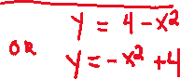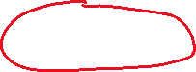

*YOU TRY #2:* 3x + y = 10



# Topic #3: The Vertical Line Test (abbreviated as VLT)

A function exists when the elements of the domain (x-values) _________________________ Not all equations are functions, but they all have a graph that shows the relationship geometrically.



Consider the graph of the equations: and



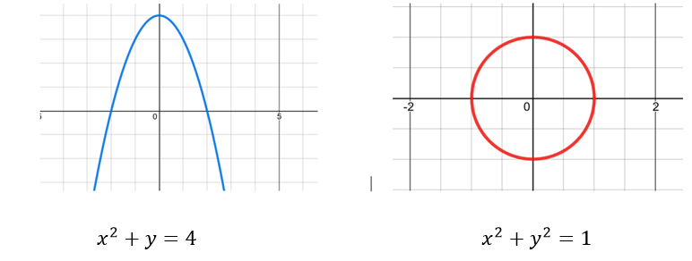



From a graphical standpoint, the graph on the left **is a function** since ________________________ Drawing a vertical line confirms this; notice that no vertical lines intersect the graph more than one time.



From a graphical standpoint, the graph on the right **is NOT a function** since ___________________________ Drawing a vertical line shows this; for the graph on the right, a vertical line can be drawn that intersects the graph in 2 points, so we have 2 different y values for the same x value. This shows visually that the graph on the right is not a function.



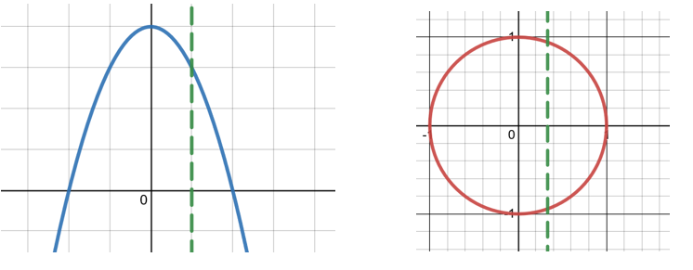



This is an example of the **________________________** which states that if a vertical line intersects a graph at more than one point, then the graph is not a function.



*YOU TRY #3* -Use the VLT to determine if each of the graphs below is or is not a function.

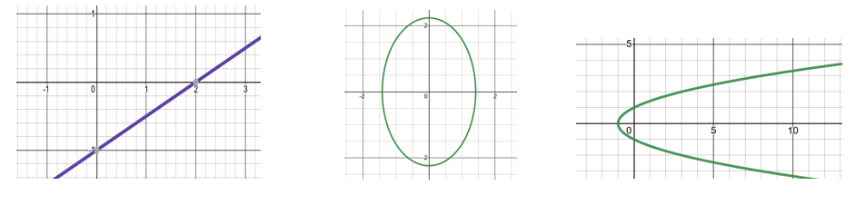



# Topic #4: Function Notation

When an equation is a function, we can use the notation: , which is read as “y is a function of x”. Recall, is the input and is the output – with function notation, y is written as .



The equation is a function since does not repeat. We can plug in values to output values. To speed up the process, the equation above can be written as and we can evaluate the function wherever it is defined for .

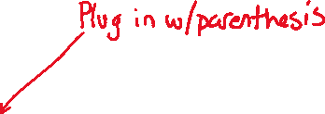

For example,

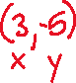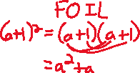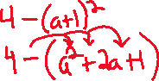

*YOU TRY #4* – Evaluate the Function

Consider the function use to evaluate:

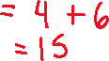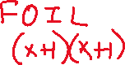

# Topic #5: Graphs of Functions

The graph of a function is the set of its ordered pairs (that satisfy the equation) plotted on the coordinate plane system.

Consider the functions: and

USE A GRAPHING CALCULATOR TO PLOT. Both have ordered pairs that satisfy the equations and both functions have a graph:



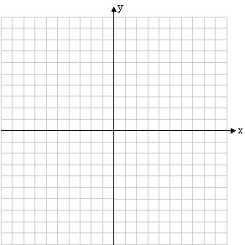

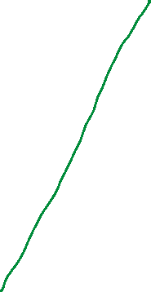

Notice that the graph for function is the graph of function shifted up 4 units.

In addition to a graph of the functions, we could also look at a table of values:

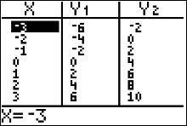

Although we could generate graphs and tables by hand, it is more efficient to use technology.

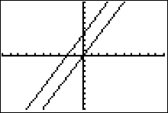

The graph and table tell us the same information and we can evaluate a function with both. For example:



# Topic #6: Analyzing the Graph of a Function



REMINDER:



Set builder notation and Interval Notation



|  | Set Builder Notation | Interval Notation |
| --- | --- | --- |
|  |  |  |
|  |  |  |
|  |  |  |

The graph of a function shows its characteristics. Here are two main features:

***(1) Domain and Range***

Recall the domain represent all _______________ for the function and the range represents all ________________



*Example #1* - Find the domain and range using the graph.

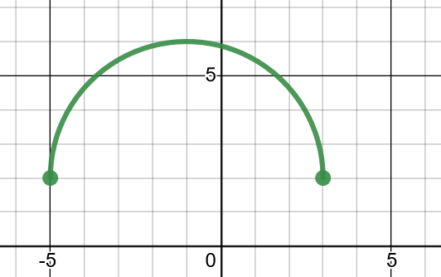

Looking from left to right (along the **x-axis**) the **domain** is all numbers between To express the values, we can write the domain as an interval

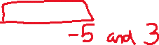

OR as a set

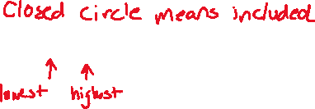

Looking from bottom to top (along the **y-axis**) what is the **range** of the function?



*Example #2 –*

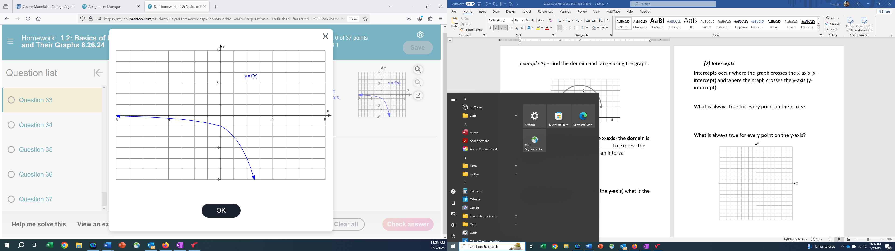

Find the Domain:



Find the Range:



***(2) Intercepts***

Intercepts occur where the graph crosses the x-axis (x-intercept) and where the graph crosses the y-axis (y-intercept).



What is always true for every point on the x-axis?

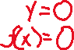

What is always true for every point on the y-axis?







*Example #3* – Find the x and y intercepts of the graph.

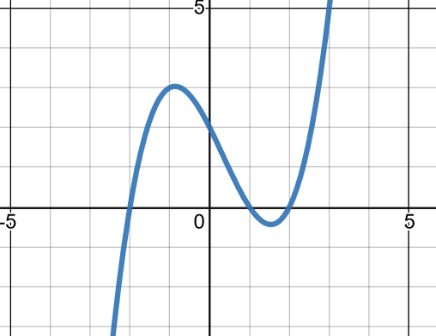



The graph crosses the x-axis three times. This graph shows that the x-intercepts are at .



The graph crosses the y-axis one time. **What is the y-intercept?**



*Example #4 –*



If the​ x-intercepts of a function are 9 and -8, then f(9)=_______ f(-8)equals_______



The​ x-intercepts, 9 and -8,

are called the​ _____________ of the function.



*Example #5 –*

Find the x-intercept and y-intercept for the following function:





*YOU TRY #5* – Analyze the Function

Use the graph of the function to answer the questions:

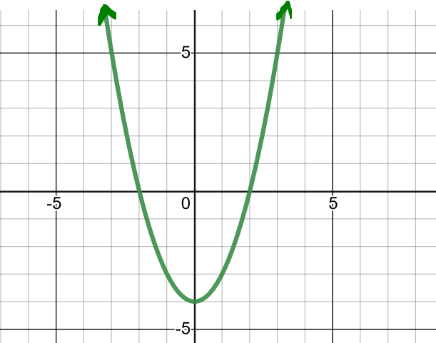



a) Find the domain and range in interval notation and set notation.

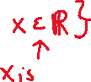

b) Find the intercepts.

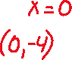

c) Evaluate



d) For what x value(s) is ?



# Topic #7: Applications of a Function – Modeling Data

Functions are often used to model the real world. The bar graph below shows the chances (as a percent) of an adult surviving to various ages after reaching 60 years old in a particular country.

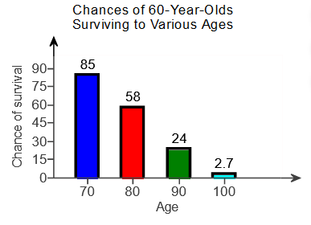

The data represents a function, where represents age (in years) and represents the chance of living to that age (as a percent). The data can be modeled with an equation, which is best done with technology.

Let x be:



Let be:



One model that fits the data shown in the graph above well is the function .

*Example #1* – Interpret the Function in Context

Use the bar graph and function model described above to answer the questions below:

1. Use the function to evaluate *g*(80) and interpret the meaning in a complete sentence.



1. Compare the value from the model to the actual value. How far off are the values?



*YOU TRY #6* - Use the function to evaluate *g*(86) and interpret its meaning.

